There are 2 datasets present in the file. Data 1 and Data 2. The primary key for both data1 and data2 is Order Id + Product ID combination (i.e. the individual datasets do not have any duplicate on this combination)

Write SQL queries for the below questions:
- How to identify the Records (Order ID + Product ID combination) present in data1 but missing in data2 (Specify the number of records missing in your answer) (Marks- 2.5)

Syntax - Select * from Datat_1_Copy as D1 Left Join Datat_2_Copy as D2
on D1.`Order ID` = D2.`Order ID`
And D1.`Product id` = D2.`Product id`
Where D2.`Order Id` is Null ;

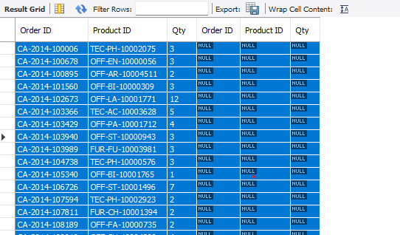

- How to identify the Records (Order ID + Product ID combination) missing in data1 but present in data2 (Specify the number of records missing in your answer) (Marks- 2.5)

Syntax - Select D2.`Order ID`, D2.`Product id`
From Datat_2_Copy as D2
Left join Datat_1_Copy as D1
On D2.`Order ID` = D1.`Order ID`
And D2.`Product id` = D1.`Product id`
Where D1.`Order Id` is Null ;
Select Count(*) As Missing_records From Datat_2_Copy as D2
Left join Datat_1_Copy as D1
On D2.`Order ID` = D1.`Order ID`
And D2.`Product id` = D1.`Product id`
Where D1.`Order Id` is Null ;
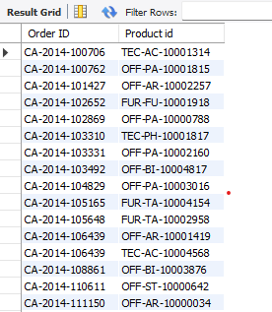



- Find the Sum of the total Qty of Records missing in data1 but present in data2 (Marks- 2.5)

Syntax - Select Sum(D2.QTY) As Total_Missing_QTY
From Datat_2_Copy as D2
Left join Datat_1_Copy as D1
On D2.`Order ID` = D1.`Order ID`
And D2.`Product id` = D1.`Product id`
Where D1.`Order Id` is Null ;


- Find the total number of unique records (Order ID + Product ID combination) present in the combined dataset of data1 and data2. (Marks- 2.5)

Syntax - Select Count(*) As Total_Unique_Records
From (Select * from datat_1_copy
union
Select * from datat_2_copy) As T;



